Oblique Prism
# Source: AI Source: Provided by: [Data Path: Persons Table -> ID Column: 1, Name_En Column: Motasem Essam] -> From: [ChatGPT] on [7/25/2026]
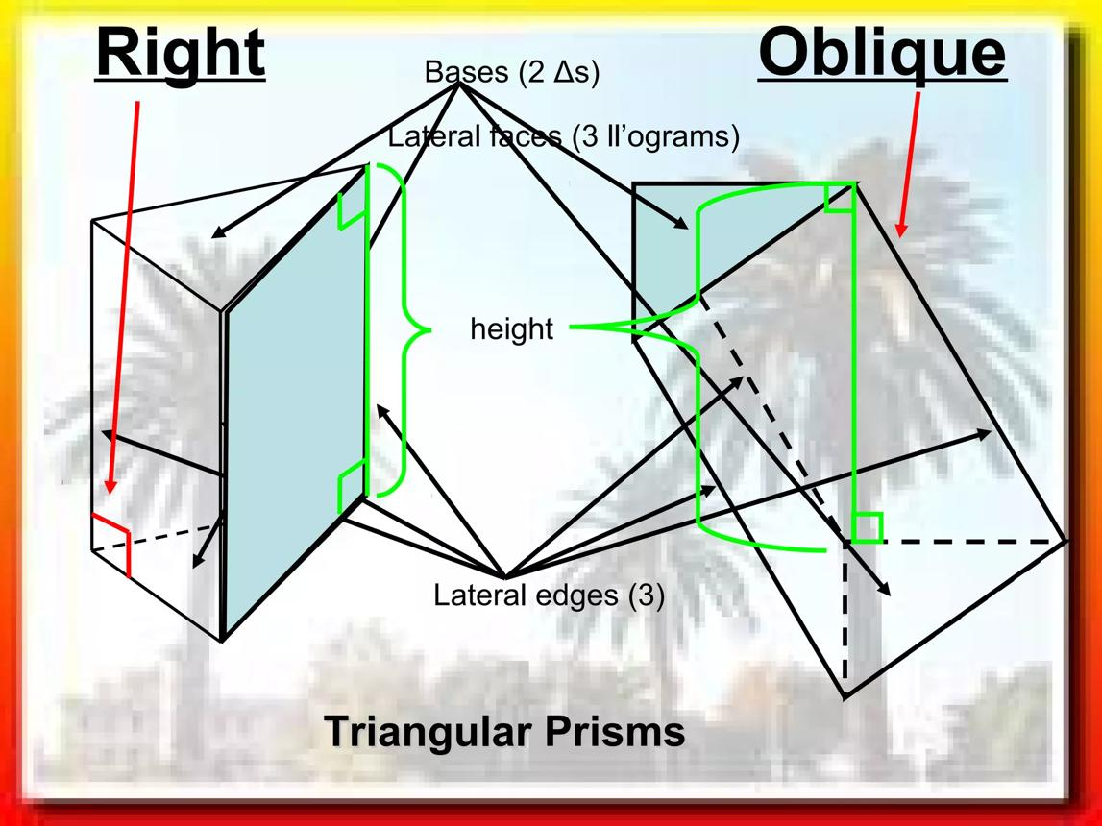
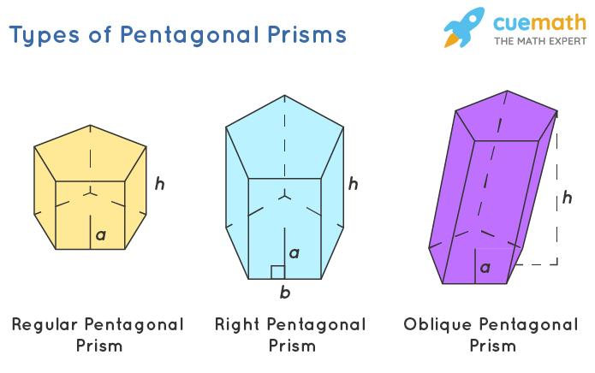
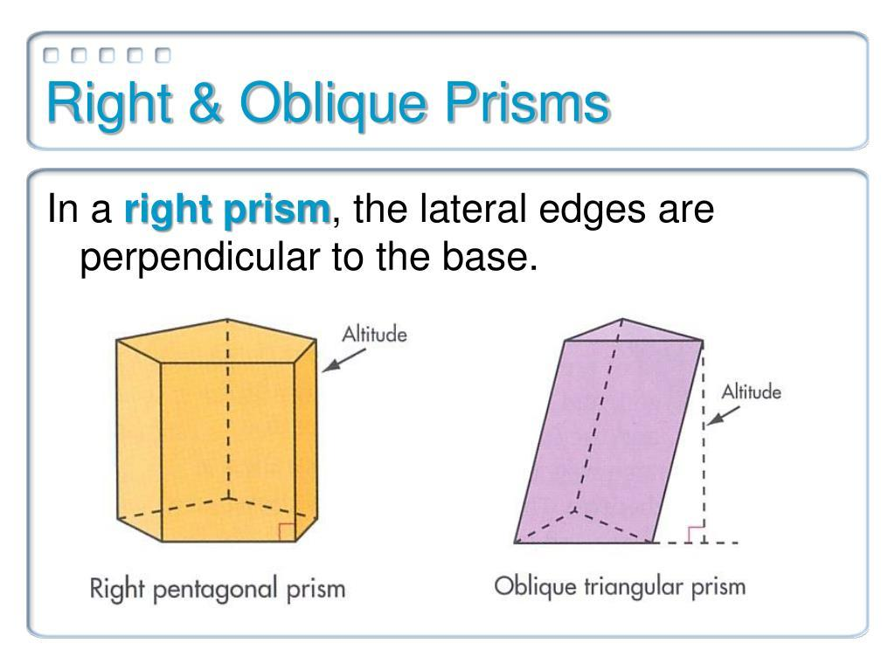

Definition
# Source: AI Source: Provided by: [Data Path: Persons Table -> ID Column: 1, Name_En Column: Motasem Essam] -> From: [ChatGPT] on [7/25/2026]
An oblique prism is a three-dimensional geometric solid with two congruent, parallel polygonal bases connected by lateral faces that are generally parallelograms. Its lateral edges are inclined to the base planes rather than perpendicular to them.
Unlike a right prism, an oblique prism leans to one side, so its lateral edges are not perpendicular to the bases.
The bases can be any polygon, such as a triangle, quadrilateral, pentagon, hexagon, or an $n$-sided polygon.

Simple Definition
# Source: AI Source: Provided by: [Data Path: Persons Table -> ID Column: 1, Name_En Column: Motasem Essam] -> From: [ChatGPT] on [7/25/2026]
An oblique prism is a prism that leans sideways instead of standing straight up.
- The two bases are identical in shape and size.
- The bases are parallel.
- The lateral edges are slanted.
- The lateral faces are parallelograms.
- The perpendicular distance between the bases is the prism's height, which is usually shorter than the lateral edges.

Classification Tree
# Source: AI Source: Provided by: [Data Path: Persons Table -> ID Column: 1, Name_En Column: Motasem Essam] -> From: [ChatGPT] on [7/25/2026]
Prisms
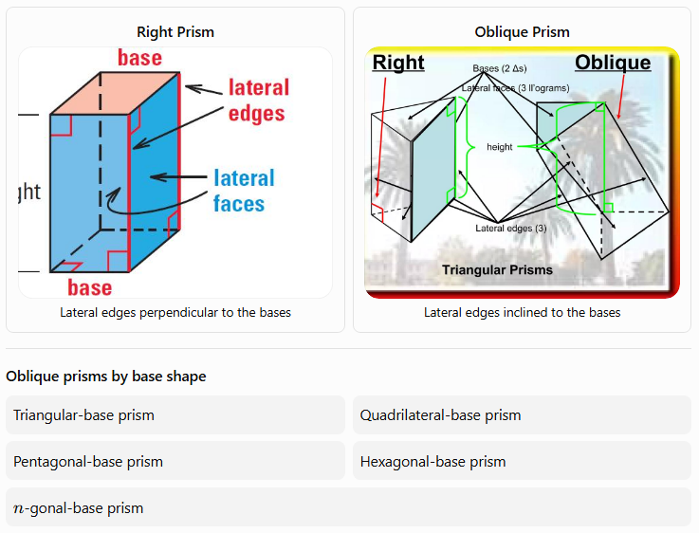
Right Prism
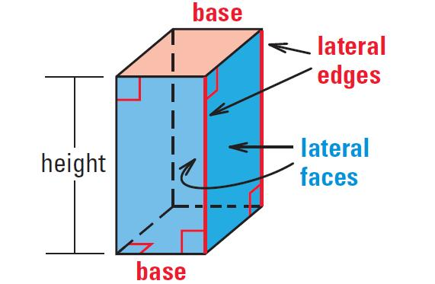
Lateral edges perpendicular to the bases
Oblique Prism
Lateral edges inclined to the bases
Oblique prisms by base shape
Triangular-base prism
Quadrilateral-base prism
Pentagonal-base prism
Hexagonal-base prism
$n$-gonal-base prism

Key Characteristics
# Source: AI Source: Provided by: [Data Path: Persons Table -> ID Column: 1, Name_En Column: Motasem Essam] -> From: [ChatGPT] on [7/25/2026]
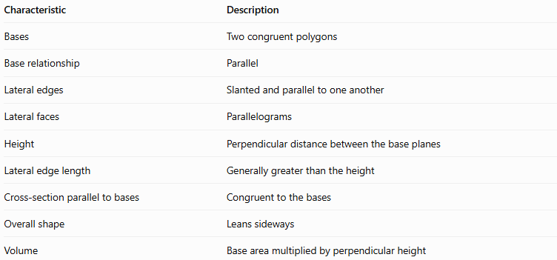
Characteristic | Description
Bases | Two congruent polygons
Base relationship | Parallel
Lateral edges | Slanted and parallel to one another
Lateral faces | Parallelograms
Height | Perpendicular distance between the base planes
Lateral edge length | Generally greater than the height
Cross-section parallel to bases | Congruent to the bases
Overall shape | Leans sideways
Volume | Base area multiplied by perpendicular height

Geometric Representation
# Source: AI Source: Provided by: [Data Path: Persons Table -> ID Column: 1, Name_En Column: Motasem Essam] -> From: [ChatGPT] on [7/25/2026]
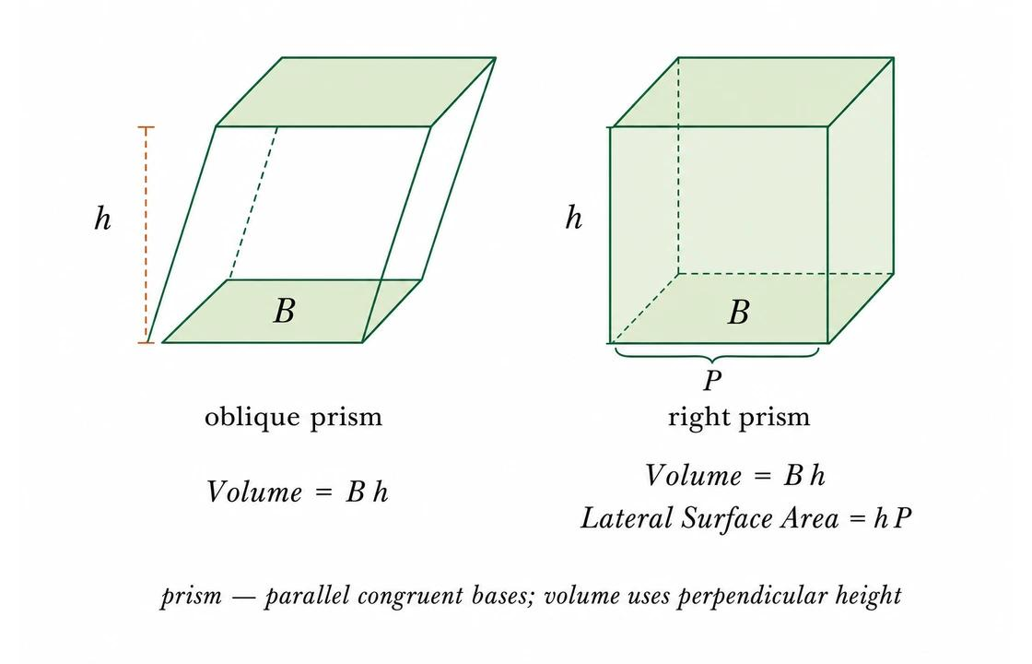
An oblique prism can be described using these components:
- Base faces: The two congruent, parallel polygons.
- Lateral faces: Parallelograms joining corresponding sides of the bases.
- Lateral edges: Slanted segments joining corresponding vertices.
- Height ($h$): The shortest perpendicular distance between the base planes.
- Lateral edge length ($L$): The length of a slanted edge; it is not generally equal to the height.
For a right prism, the lateral edges are perpendicular to the bases, so $L=h$. For an oblique prism, $L$ is generally greater than $h$.

Mathematical Properties and Formulas
# Source: AI Source: Provided by: [Data Path: Persons Table -> ID Column: 1, Name_En Column: Motasem Essam] -> From: [ChatGPT] on [7/25/2026]
Let:
- $n$ = number of sides of each base polygon
- $B$ = area of one base
- $p$ = perimeter of one base
- $h$ = perpendicular height
- $L$ = lateral edge length
- $A_{L}$ = lateral surface area
- $A_{T}$ = total surface area
- $V$ = volume

Number of faces, edges, and vertices
# Source: AI Source: Provided by: [Data Path: Persons Table -> ID Column: 1, Name_En Column: Motasem Essam] -> From: [ChatGPT] on [7/25/2026]
For an $n$-gonal prism:
$$F=n+2$$
$$E=3n$$
$$N_{v}=2n$$
Here, $F$ is the number of faces, $E$ is the number of edges, and $N_{v}$ is the number of vertices.
For example, an oblique pentagonal prism has:
- $F=5+2=7$ faces
- $E=3\left(5\right)=15$ edges
- $N_{v}=2\left(5\right)=10$ vertices

Volume
# Source: AI Source: Provided by: [Data Path: Persons Table -> ID Column: 1, Name_En Column: Motasem Essam] -> From: [ChatGPT] on [7/25/2026]
The volume formula is the same for right and oblique prisms:
$$\boxed{V=Bh}$$
The height $h$ must be the perpendicular distance between the bases, not the length of a slanted lateral edge.

Lateral surface area
# Source: AI Source: Provided by: [Data Path: Persons Table -> ID Column: 1, Name_En Column: Motasem Essam] -> From: [ChatGPT] on [7/25/2026]
For an oblique prism, the lateral surface area is the sum of the areas of its parallelogram-shaped lateral faces:
$$\boxed{A_{L}=A_{1}+A_{2}+⋯+A_{n}}$$
Each lateral parallelogram's area is its base-edge length multiplied by the perpendicular altitude within that face.
In general, $A_{L}≠ph$ for an oblique prism. The formula $A_{L}=ph$ applies to a right prism, where all lateral faces are rectangles.

Total surface area
# Source: AI Source: Provided by: [Data Path: Persons Table -> ID Column: 1, Name_En Column: Motasem Essam] -> From: [ChatGPT] on [7/25/2026]
The total surface area includes both bases and all lateral faces:
$$\boxed{A_{T}=A_{L}+2B}$$

Relationship between height and lateral edge length
# Source: AI Source: Provided by: [Data Path: Persons Table -> ID Column: 1, Name_En Column: Motasem Essam] -> From: [ChatGPT] on [7/25/2026]
If a lateral edge has length $L$ and makes an angle $α$ with the base plane, then:
$$\boxed{h=L\sin{α}}$$
Therefore,
$$\boxed{L=\frac{h}{\sin{α}}}$$
where $0^{∘}<α≤{90}^{∘}$. At ${90}^{∘}$, the prism is right rather than oblique.

Euler's formula
# Source: AI Source: Provided by: [Data Path: Persons Table -> ID Column: 1, Name_En Column: Motasem Essam] -> From: [ChatGPT] on [7/25/2026]
For a convex oblique prism:
$$\boxed{N_{v}-E+F=2}$$
Substituting the general counts:
$$2n-3n+\left(n+2\right)=2$$
Thus, Euler's formula holds for convex oblique prisms as well as right prisms.

Worked Examples
# Source: AI Source: Provided by: [Data Path: Persons Table -> ID Column: 1, Name_En Column: Motasem Essam] -> From: [ChatGPT] on [7/25/2026]
Example 1: Finding the number of faces, edges, and vertices
Problem: An oblique hexagonal prism has hexagonal bases. Find its faces, edges, and vertices.
Solution:
Here, $n=6$.
Faces:
$$F=n+2=6+2=\boxed{8}$$
Edges:
$$E=3n=3\left(6\right)=\boxed{18}$$
Vertices:
$$N_{v}=2n=2\left(6\right)=\boxed{12}$$
Answer: 8 faces, 18 edges, and 12 vertices.
Example 2: Calculating volume
Problem: An oblique prism has a base area of $36{\text{ cm}}^{2}$ and a perpendicular height of $10\text{ cm}$. Find its volume.
Solution:
$$V=Bh$$
$$V=36\left(10\right)=\boxed{360{\text{ cm}}^{3}}$$
Answer: The volume is $360{\text{ cm}}^{3}$.
Remember that the perpendicular height is used, even if the prism's lateral edges are longer.
Example 3: Finding the perpendicular height
Problem: A lateral edge of an oblique prism is $13\text{ cm}$ long and makes an angle of approximately ${67.38}^{∘}$ with the base plane. Find the perpendicular height.
Solution:
$$h=L\sin{α}$$
$$h=13\sin\left({67.38}^{∘}\right)$$
$$h≈13\left(0.923\right)=\boxed{12\text{ cm}}$$
Answer: The perpendicular height is approximately $12\text{ cm}$.
Example 4: Calculating total surface area
Problem: An oblique prism has a base area of $24{\text{ cm}}^{2}$. Its four lateral parallelograms have areas of $30$, $36$, $30$, and $36{\text{ cm}}^{2}$. Find the total surface area.
Solution:
First, calculate the lateral surface area:
$$A_{L}=30+36+30+36=132{\text{ cm}}^{2}$$
Then add the two bases:
$$A_{T}=A_{L}+2B$$
$$A_{T}=132+2\left(24\right)$$
$$\boxed{A_{T}=180{\text{ cm}}^{2}}$$
Answer: The total surface area is $180{\text{ cm}}^{2}$.
Example 5: Verifying Euler's formula
Problem: Verify Euler's formula for an oblique triangular prism.
A triangular prism has 5 faces, 9 edges, and 6 vertices.
$$N_{v}-E+F=2$$
$$6-9+5=\boxed{2}$$
Answer: Euler's formula is satisfied.

Types of Oblique Prisms by Base Shape

Oblique Triangular Prism
# Source: AI Source: Provided by: [Data Path: Persons Table -> ID Column: 1, Name_En Column: Motasem Essam] -> From: [ChatGPT] on [7/25/2026]
Has two parallel triangular bases connected by three parallelogram lateral faces. It has 5 faces, 9 edges, and 6 vertices.
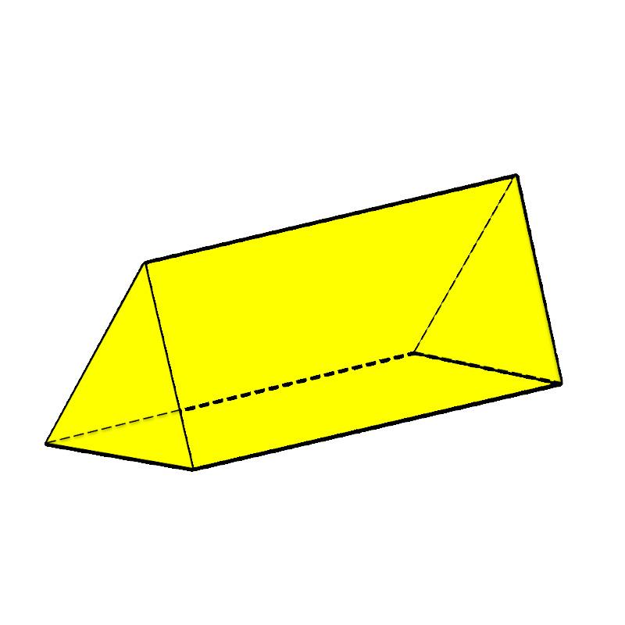

Oblique Quadrilateral Prism
# Source: AI Source: Provided by: [Data Path: Persons Table -> ID Column: 1, Name_En Column: Motasem Essam] -> From: [ChatGPT] on [7/25/2026]
Has two congruent quadrilateral bases and four lateral faces. It has 6 faces, 12 edges, and 8 vertices.
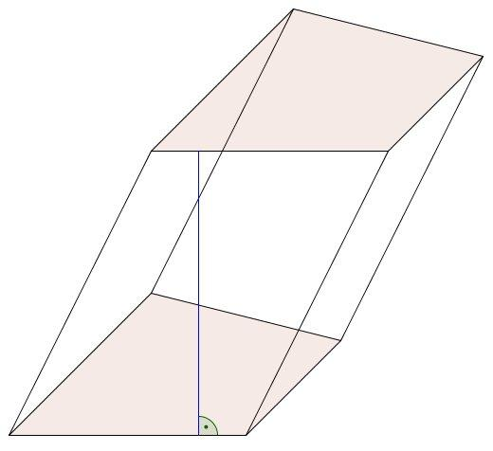

Oblique Pentagonal Prism
# Source: AI Source: Provided by: [Data Path: Persons Table -> ID Column: 1, Name_En Column: Motasem Essam] -> From: [ChatGPT] on [7/25/2026]
Has pentagonal bases and five lateral faces. It has 7 faces, 15 edges, and 10 vertices.
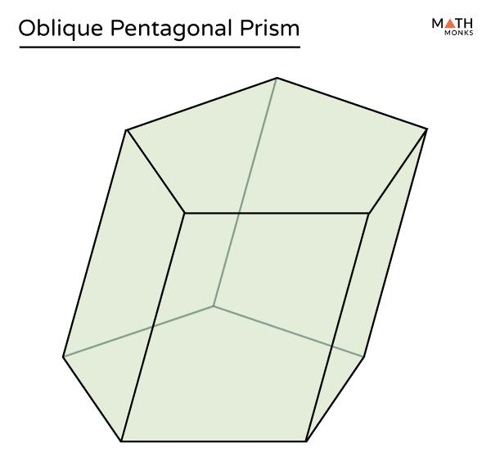

Oblique Hexagonal Prism
# Source: AI Source: Provided by: [Data Path: Persons Table -> ID Column: 1, Name_En Column: Motasem Essam] -> From: [ChatGPT] on [7/25/2026]
Has hexagonal bases and six lateral faces. It has 8 faces, 18 edges, and 12 vertices.
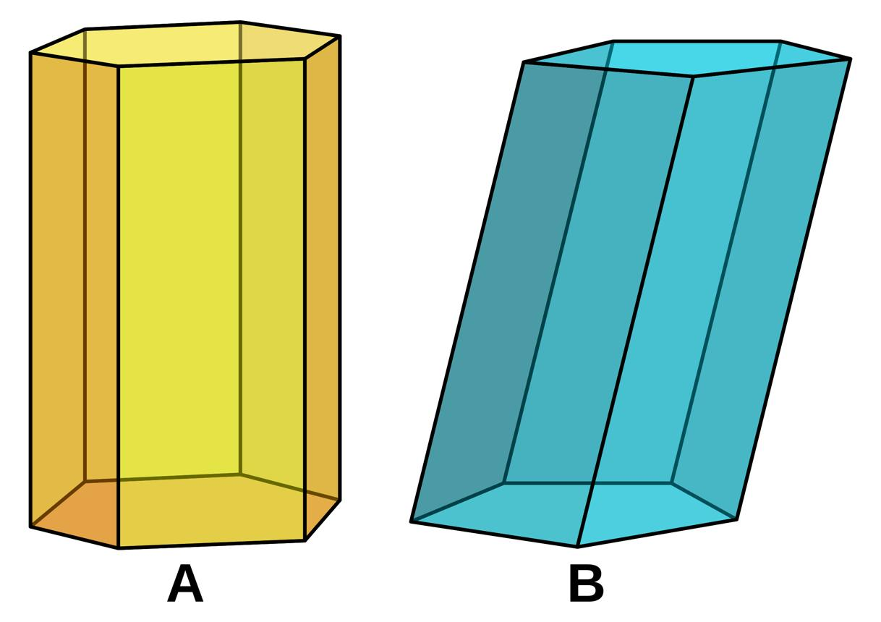

Oblique Prism vs. Right Prism
# Source: AI Source: Provided by: [Data Path: Persons Table -> ID Column: 1, Name_En Column: Motasem Essam] -> From: [ChatGPT] on [7/25/2026]
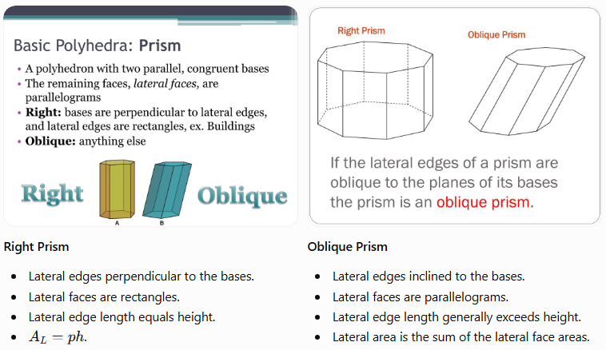
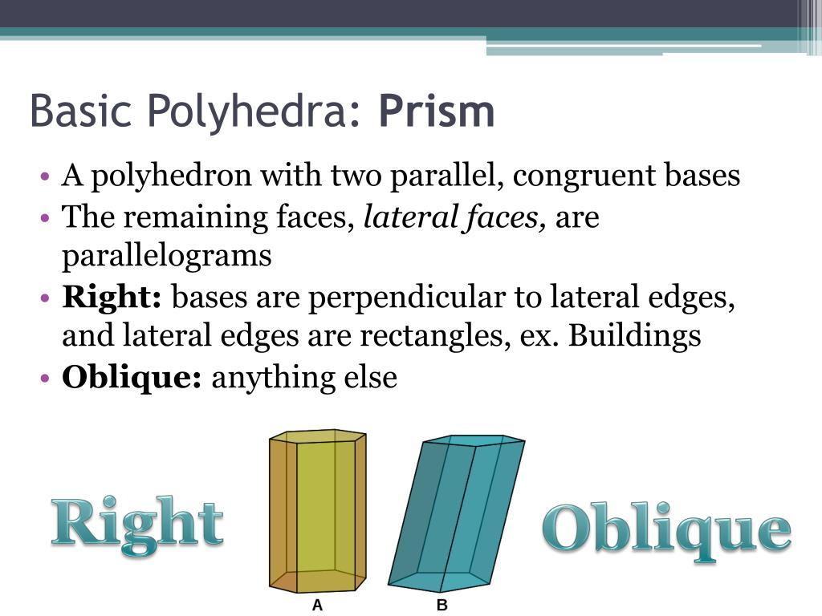
Right Prism
- Lateral edges perpendicular to the bases.
- Lateral faces are rectangles.
- Lateral edge length equals height.
- $A_{L}=ph$.
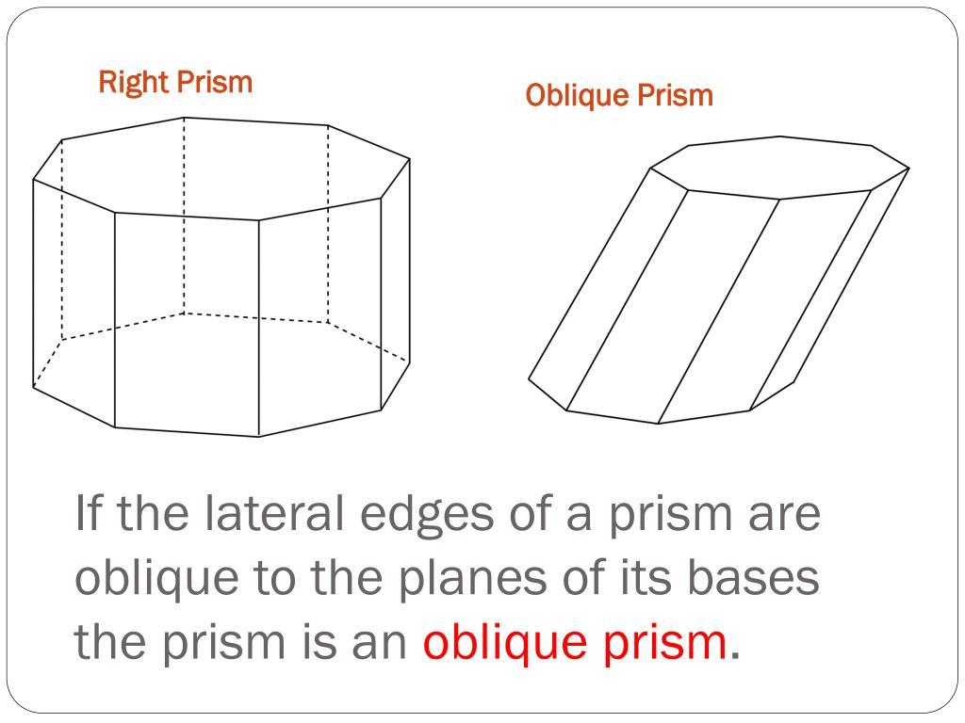
Oblique Prism
- Lateral edges inclined to the bases.
- Lateral faces are parallelograms.
- Lateral edge length generally exceeds height.
- Lateral area is the sum of the lateral face areas.
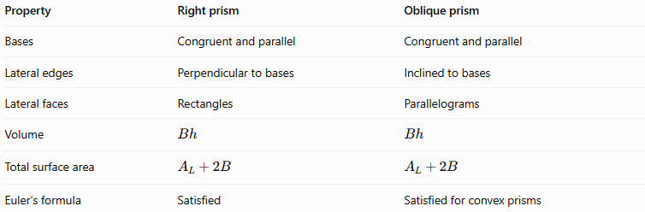
Property | Right prism | Oblique prism
Bases | Congruent and parallel | Congruent and parallel
Lateral edges | Perpendicular to bases | Inclined to bases
Lateral faces | Rectangles | Parallelograms
Volume | $$Bh$$ | $$Bh$$
Total surface area | $$A_{L}+2B$$ | $$A_{L}+2B$$
Euler's formula | Satisfied | Satisfied for convex prisms
Both types have the same general counts of faces, edges, and vertices for a given base polygon. Their main difference is their spatial orientation.

Real-World Applications
# Source: AI Source: Provided by: [Data Path: Persons Table -> ID Column: 1, Name_En Column: Motasem Essam] -> From: [ChatGPT] on [7/25/2026]
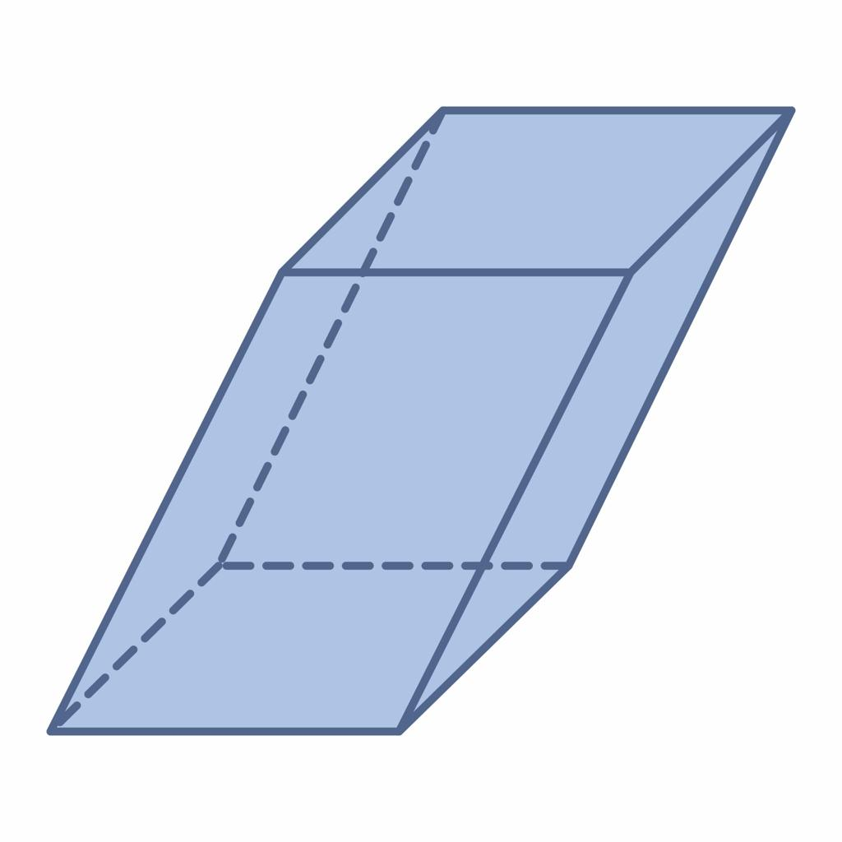
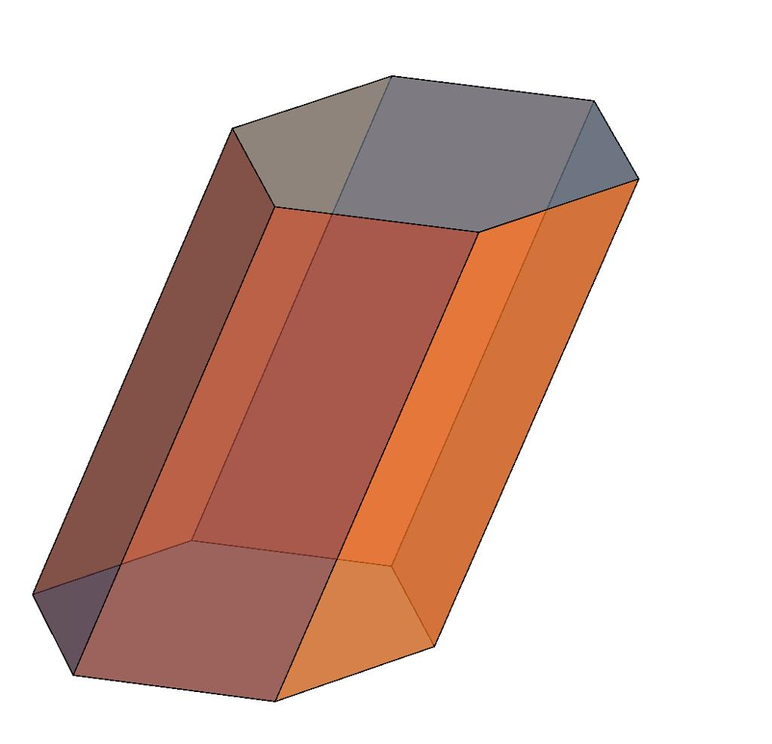
Oblique-prism geometry can help describe or model:
- Architecture: Slanted structural forms and inclined building elements.
- Engineering: Components with parallel ends and inclined sides.
- Geometric modeling: Three-dimensional solids in mathematics, CAD, and computer graphics.
- Manufacturing: Prismatic parts whose side faces are inclined rather than perpendicular to their ends.
- Mathematics education: Understanding the difference between perpendicular height and slanted edge length.
These are examples of where oblique-prism geometry may be useful; not every slanted object is an exact oblique prism.

Key Points
# Source: AI Source: Provided by: [Data Path: Persons Table -> ID Column: 1, Name_En Column: Motasem Essam] -> From: [ChatGPT] on [7/25/2026]
- An oblique prism has two congruent, parallel polygonal bases.
- Its lateral edges are inclined to the base planes.
- Its lateral faces are parallelograms.
- Its height is the perpendicular distance between the bases.
- Its volume is $V=Bh$.
- Its total surface area is $A_{T}=A_{L}+2B$.
- Its lateral surface area is generally not $ph$.
- For an $n$-gonal prism, $F=n+2$, $E=3n$, and $N_{v}=2n$.
- Convex oblique prisms satisfy Euler's formula.

Conclusion
# Source: AI Source: Provided by: [Data Path: Persons Table -> ID Column: 1, Name_En Column: Motasem Essam] -> From: [ChatGPT] on [7/25/2026]
An oblique prism is a prism whose lateral edges are inclined rather than perpendicular to its parallel, congruent bases. Its slanted shape distinguishes it from a right prism, but both share the same basic structure and volume formula.
The most important distinction is between the lateral edge length and the perpendicular height. The height determines the volume, while the actual dimensions of the lateral parallelograms determine the lateral surface area.

